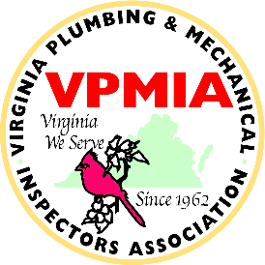

Virginia Plumbing and Mechanical Inspectors Association
New Membership Membership Renewal □
Members of the Virginia Plumbing and Mechanical Inspectors Association shall support the Association’s mission, perform all assigned duties and abide by the Association’s Constitution and By-Laws.
Membership dues shall cover the period from January 1st to December 31st. Payments received after January 1st shall only cover the period through December 31 ^{st} of that year.
□ I am a Voting Member of ICC

Check the Appropriate Membership Category Below
- Active: $45.00 - I am a Governmental employee actively engaged in plumbing or mechanical code enforcement.
- Associate: $45.00 - I am engaged in the manufacture, installation, sale or design of plumbing or mechanical systems or products.
- Retired: $10.00 - I am a former Active or Associate member who is retired.)
- Student: $10.00 - I am engaged in the study of plumbing or mechanical codes or study of plumbing or mechanical system design.)
Contact Information

Name: Title:

Jurisdiction, Firm, School, or Retired:

Address:
City: |  | State: | Zip Code:
Phone: ( | ) Ext: | Fax: ( | )
Email: |  |  | Date: / /

Make Checks Payable To:
Virginia Plumbing and Mechanical Inspectors Association (VPMIA)
Mail To:
Christopher Martin
5486 Saddler Lane
Woodbridge,VA 22193
cmmartin@arlingtonva.us

Membership dues paid to The Virginia Plumbing and Mechanical Inspectors Association (“VPMIA”) are not tax deductible as charitable contributions for Federal income tax purposes. Furthermore, the tax deductibility of dues paid to VPMIA under other sections of the Internal Revenue Code (i.e. as an ordinary and necessary business expense) is subject to restrictions imposed as a result of lobbying activities. VPMIA estimates that the nondeductible lobbying portion of your dues is 3%.

Date Paid: Check #: Amount: $ .00

